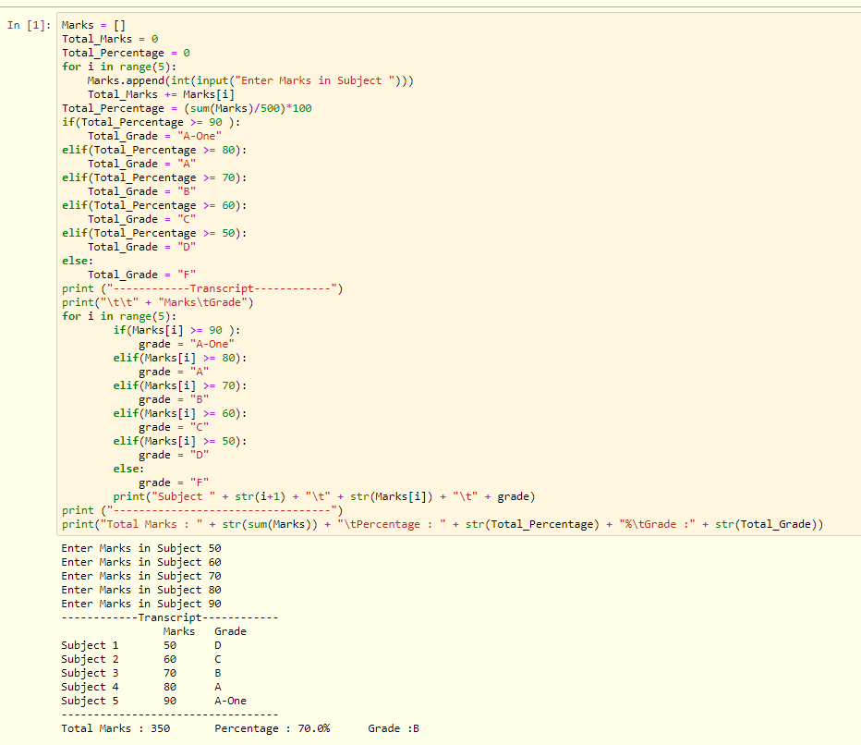Task 1 Output Screenshot:

Task 2 Output Screenshot:

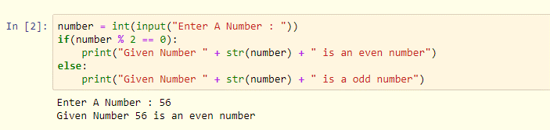

Task 3 Output Screenshot:

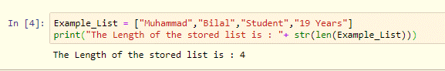

Task 4 Output Screenshot:

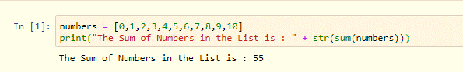

Task 5 Output Screenshot:

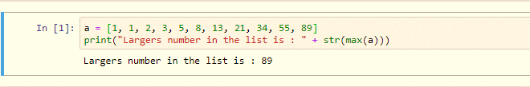

Task 6 Output Screenshot:

